

**Appendix 1 – Block Plan**

**17/02537/CND2 – St Hilda’s College**

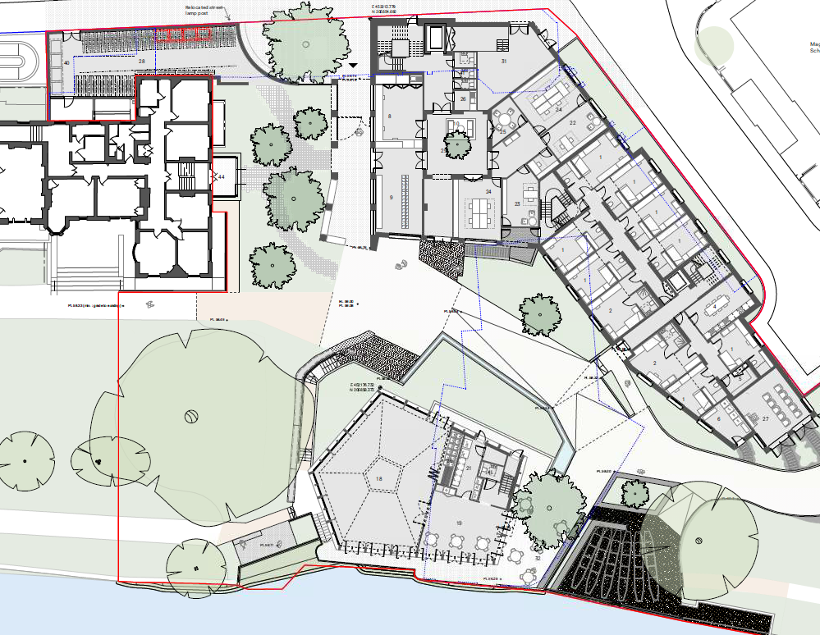

Boundary Building (new porters lodge, offices and student rooms

Proposed Pavillion

New Courtyard

New Entrance to College

Proposed Tower

Cowley Place

Cowley Place